Background info for candidate

You are asked to see a 59 year old male on the ICU who is 12 hours post-a cardiac arrest following an anterio-lateral MI. He has a past medical history of Type 2 diabetes and IHD. The nurse calls you as his heart rate is suddenly abnormal.

Progress of case
Initial examination:
A – SACETT size 8.0
B – Normal chest expansion and equal air entry on auscultation, SpO2 91% on initial assessment, Bipap mode RR 12
C - Pulse initially 48 then drops to 29 and BP 110/55 then drops to 85/40, cold, shutdown peripheries, ECG: 3 degree heart block,
D - GCS ETV1M1, PEARL, Prop +Fent sedation infusions
E - Temp 35.9, glucose 7.2,

Most appropriate option: pacing via defib = successful, ensure adequate sedation,
If appropriate management - HR returns to 80, BP to 110/85

If using drugs e.g. Noradrenaline – BP initially rises to 90 then drops to 70 systolic

If no management instituted – more unstable (BP to 65/30, then asystole)

Post SR – need to correct electrolytes and identify and treat block. Needs cardiology review

Available help:
- Second instructor can act as senior ICU SHO, (if senior help requested)
- ICU registrar (via phone only – in A&E)/Cardiology reg (phone)
- ICU consultant (via phone only – at home)

Expectation from candidate
- Call for help/Situational awareness/Use of team
- Correct diagnosis
- Institute appropriate management as per ALS guidelines
- Think of underlying cause, , involve cardiologists

Set-up

Patient: Patient is ventilated on BIPAP on 60% with
Infusions running: Noradrenaline low dose (2mls/hour single strength). Propofol 40mgs/ hour . Fentanyl 50mcg/hour
Arterial line and central line, NGT, etc in situ.

Staff present: bedside nurse

Initial observations: SpO2 96%, RR 25, HR 48 (then dropping to 29), BP 110/55 (then dropping to 85/40)

Equipment available:
- Resus trolley
- Defibrillator
- Airway equipment including: Facemasks, Ambu bag, Water’s circuit, Bougie, Laryngoscopy blades, Selection of ETTs, Ties
- Drugs including: Propofol, Midazolam, Fentanyl, Suxamethonium, Rocuronium, Adrenaline minijet, Ephedrine, Metaraminol, Atropine minijet
- Anti-arrhythmics including: atropine, gycopyrulate

Aim

To be able to safely manage the bradycardiac patient

Key points

Discuss peri-arrest management of bradycardia

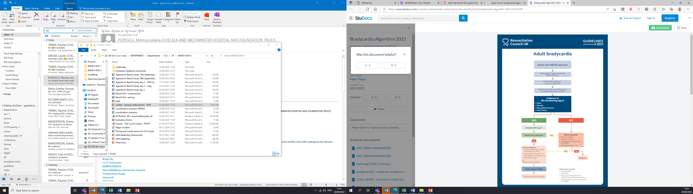

Discuss the drugs options

Discuss the pacing options

Objectives

- Technical
  - To be able to recognise complete heart block
  - To treat bradycardia appropriately as per ALS guidelines
    - ?Adverse features – pace with defib
  - To treat cardiogenic shock appropriately

- Non-technical
  - Task management
    - Prioritising management of arrhythmia
  - Team working
    - coordinating activities – sedation/anesthesia and pacing /Exchanging information
  - Situation awareness
    - Gathering information/Anticipation of problems
  - Decision making
    - Aware of options for treatment/Balancing risks/Re-evaluating post intervention (repeat ECG post pacing and investigate cause)

